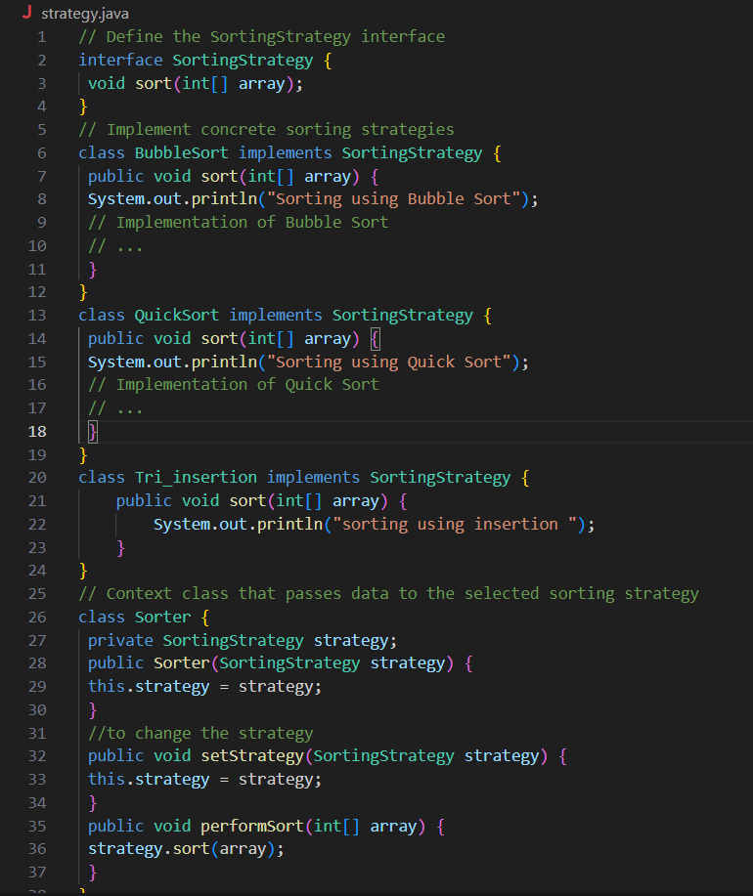**Approach 1 :**

**Approach 1 Result:**

**Approach 2 :**

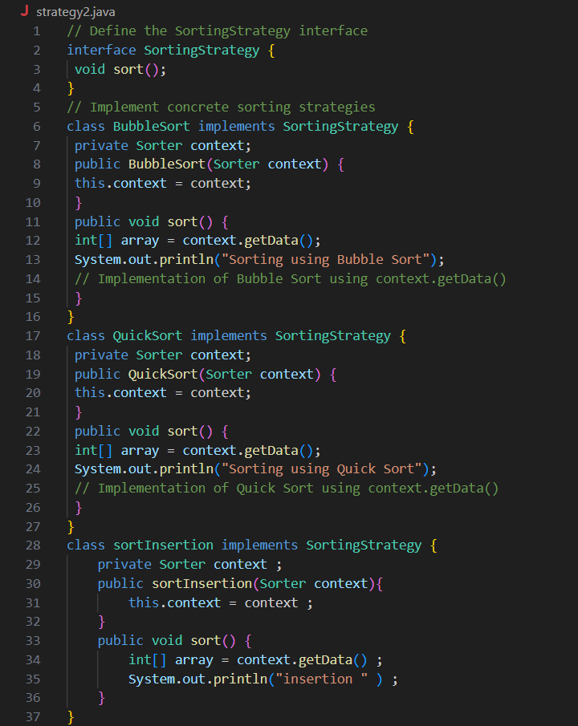

**Approach 2 result :**

